Poly Cracker Company – Payroll System

The Poly Cracker Company has four types of employees: Commissioned (e.g. Bob Loblaw), Salaried (e.g. Sue Me), Piece Workers (e.g. Tina Zena) and Managers (e.g. Richard Rich).

The formulae for calculating their monthly pay are:

* **Commissioned**: Base salary of $2000 per month + 10% of gross sales
* **Salaried**: 50,000 / year + .01 per year of service
* **Piece Workers**: $1 per unit
* **Managers**: Base salary of 100,000 per year + monthly bonus

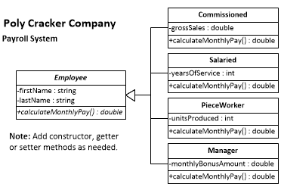

During this month the following data was accumulated on the four individuals in the database

(In other words, these are the values passed to the constructors).

Bob Loblaw - had gross sales of $40,000  
Sue Me - has 10 years of service  
Tina Zena - produced 1000 units  
Richard Rich - had a $2000 bonus this month

# Exercise Instructions:

Create a console application that demonstrates polymorphism.

* Create the 5 classes as outlined in the provided class diagram. Note: You may need to add properties, constructors and/or get/set methods.
* Implement the different pay calculations in the appropriate classes.
* Create a single ArrayList to hold employees of all salary types.
* Create an instance of each employee and add to the list.
* Using a polymorphic routine, build a simple report to display the company payroll (a list of names, employee type, and monthly pay) in the console.
* Hint: Look up **.getClass().getSimpleName()**
* **Think polymorphism** - don’t just build a toString() method with all the data in it.

# Sample Report

